**Features:**

**- User Registration:** Allows users to sign up and update their interests.

- **Create Recipe Ideas via AI Assistant**: Users can input their own ideas or get help from AI Assistant to generate ideas by providing user-friendly prompts.

- **Submit Ideas:** Users can submit their ideas to request for custom recipe suggestions from chefs.

- **View Recipes:** Users can view custom recipes submitted by chefs against their ideas.

- **Order Recipe:** Users can select one or more recipes and order in their required quantities.

**API calls:**

1. **User Registration/Login Screen**

App: Customer

APIs:

POST /users/signup

Use: Create a new user account using google

POST /users/login

Use: Authenticate a user

POST /users/logout

Use: Log outs user

2. **User Profile Screen**

App: Customer

API:

PATCH /users/

Use: Update user's dietary preferences and health considerations

3. **Generate Idea Screen**

App: Customer

APIs:

POST users/ideas

Use: Create a new idea (self-generated or AI-assisted) in customer's ideas table

PATCH users/ideas/{id}

Use: Update status of idea to submitted when customer submits an idea

POST /vendor/ideas **(call vendor API to submit idea)**

Use: Submit the idea to vendor's ideas table

4. **Recipe Screen**

App: Customer

APIs:

GET users/ideas/{status}

Use: Retrieve user's ideas according to their statuses

GET users/ideas/recipes

Use: Fetch recipes associated with ideas from generated_recipes table

5. **Order Screen**

App: Customer

GET users/orders (Optional not requirement – added just to allow customers to view order status after placing orders)

Use: View order history of user

6. **Cart Screen**

App: Customer

API:

POST users/order

Use: Create a new order for a recipe in customer's order table

POST /vendor/orders **(call vendor API to submit order)**

Use: Place the order in vendor's order table

**Vendor App APIs (called by Customer App)**

POST /vendor/ideas

Use: Submit an idea to the vendor for recipe creation

POST /vendor/orders

Use: Place an order with the vendor

**Customer App APIs (called by Vendor App)**

POST /recipes

Use: Submit a generated recipe to the customer app

PATCH /orders/{id}

Use: Update the status of an order (e.g., when order is completed)

**Screens :**

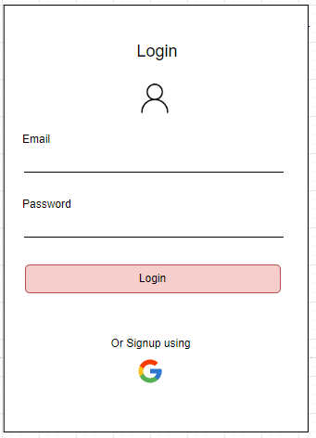

**Flow:**

**As a user, I want to log in to my account, so that I can access the application's features and services.**

* **Acceptance Criteria:**
  + I can enter my email and password in the provided input fields.
  + There is a "Login" button that allows me to submit my login credentials.
  + If my email and password are correct, I am successfully logged in and redirected to the appropriate page.
  + If my login attempt fails, an error message is displayed, informing me of incorrect credentials.
  + I can see an option to sign up using Google, which provides an alternative way to log in via Google OAuth.

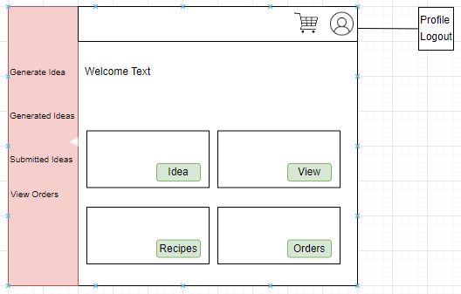

* **As a logged-in user, I want to see a home page with basic instructions and guidelines on how to use the app, so that I can easily understand how to navigate and utilize the app's features.**
* **Acceptance Criteria:**
  + The home page provides clear text and guidelines on how to use the app's various features, such as generating ideas and viewing orders.
* **As a logged-in user, I want to have a sidebar with options to navigate to "Generate Idea," "Generated Ideas," "Submitted Ideas," and "View Orders," so that I can easily access recipe generation and order management features.**
* **Acceptance Criteria:**
  + The sidebar contains four navigational options: "Generate Idea," "Generated Ideas," "Submitted Ideas," and "View Orders."
  + I can click on each option in the sidebar to be redirected to the corresponding page.
  + The sidebar is consistently available on each page to ensure easy access to these key features.
* **As a logged-in user, I want to have a navigation bar that includes a cart button, so that I can review and manage the items I’ve added to my cart.**
* **Acceptance Criteria:**
  + The navigation bar contains a cart button that, when clicked, shows me the items in my cart.
  + I can review and place orders directly from the cart.
  + The cart button is visible and easily accessible from any page in the app.

**As a logged-in user, I want to be able to click on the profile icon to either view my profile or log out, so that I can manage my account and exit the app securely.**

* **Acceptance Criteria:**
  + Clicking the profile icon reveals a dropdown menu with options to "View Profile" and "Logout."
  + Clicking "View Profile" takes me to a page where I can view and edit my profile details.
  + Clicking "Logout" securely logs me out of the application and takes me back to the login page.
  + After logging out, I am unable to access the app's features until I log in again.

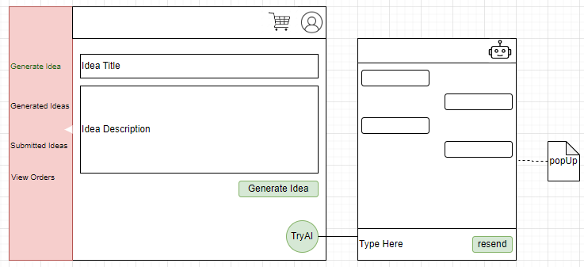- As a logged-in user, I want to create innovative recipe ideas by providing a title and description directly, so that I can suggest my own recipes.

- **Acceptance Criteria:**

- I can enter a title and description for my recipe idea.

- My idea is saved in the idea database for later use or submission.

- As a logged-in user, I want to interact with an AI chatbot to generate recipe ideas, so that I can get creative suggestions and refine them as needed.

- **Acceptance Criteria:**

- I can interact with the AI chatbot to get recipe prompts.

- The AI-generated idea is saved in the idea database for later use or submission.

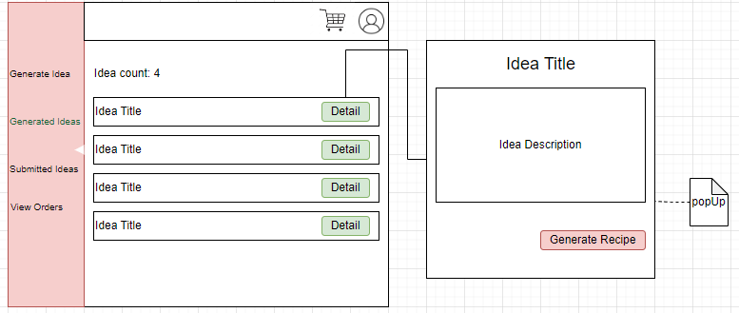

As a logged-in user, when I click on the “Generate Idea” section, I want to see a list of recipe ideas with the total count displayed at the top. Each idea should have a “Details” button, which, when clicked, opens a popup showing the detailed description of the idea. At the end of the popup, I want a “Submit” button to submit the recipe idea to the vendor system.

**Acceptance Criteria:**

- The “Generated Idea” section displays a list of recipe ideas with a count of total ideas at the top.

- Each idea in the list has a “Details” button.

- Clicking the “Details” button opens a popup with a detailed description of the selected idea.

- The popup includes a “Submit” button at the bottom.

- Clicking the “Submit” button sends the recipe idea to the vendor system.

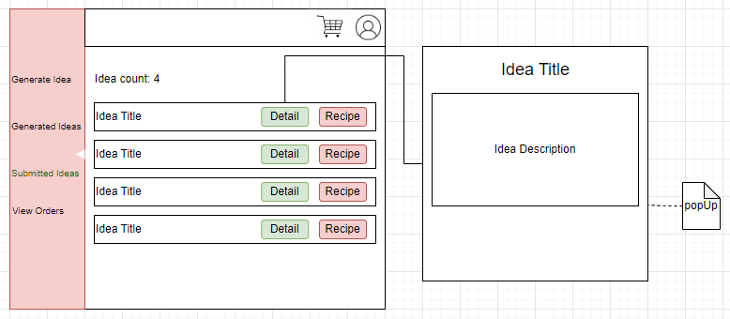

As a logged-in user, when I click on the “Submitted Ideas” section, I want to see a list of recipe ideas with the total count displayed at the top. Each idea should have a “Details” button and a “Recipe” button. Clicking the “Details” button should open a popup showing the detailed description of that specific idea.

**Acceptance Criteria:**

- The “Submitted Ideas” section displays a list of recipe ideas with a count of total ideas at the top.

- Each idea in the list has both a “Details” button and a “Recipe” button.

- Clicking the “Details” button opens a popup with a detailed description of the specific idea.

- The popup shows only the description of the idea and does not include any other functionality.

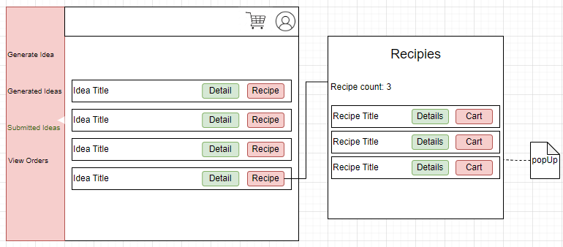

As a logged-in user, when I click on the “Recipe” button in Submitted Ideas section, I want to see a list of recipes generated by the vendor system with the total count of recipes displayed at the top. Each recipe should have a “Details” button and a “Cart” button. Clicking “Details” opens a popup showing the detailed description of that specific detail. Similarly, if I click on “Cart” button I want that specific recipe to be added to the cart.

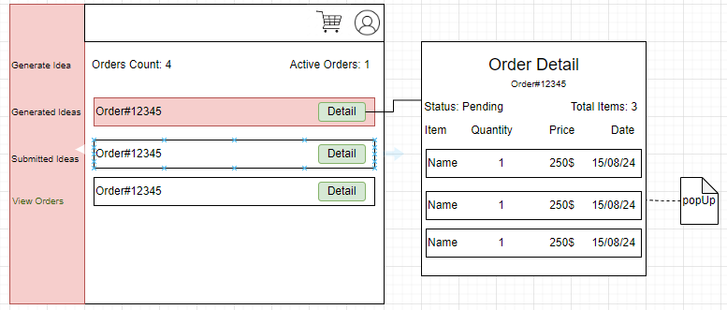

* **As a logged-in user, I want to view my order history in descending order, so that I can see the most recent orders at the top of the list.**
* **Acceptance Criteria:**
  + I can click on "View Orders" to display my order history.
  + The orders are displayed in descending order, with the most recent orders shown first.
  + Each order is shown with an order number and a "Detail" button.
  + I can see the total number of orders and the count of active orders at the top of the screen.
* **As a logged-in user, I want to view the details of a specific order by clicking the "Detail" button, so that I can see information such as items, quantities, and order status.**
* **Acceptance Criteria:**
  + Each order in the list has a "Detail" button beside it.
  + When I click the "Detail" button, the details of the selected order are displayed.
  + The order details include the order status, total items, and a list of items with their quantity, price, and date.
  + The information is displayed in a pop-up or side panel for easy reference.

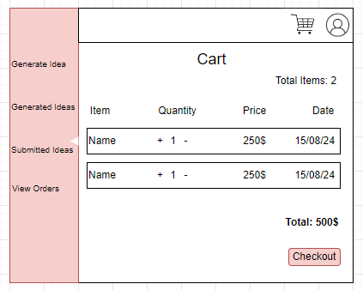

- As a logged-in user, I want to select one or more recipes and add them to my cart, so that I can review my selection before placing an order.

- Acceptance Criteria:

- I can add selected recipes to the cart.

- The cart displays a summary of selected recipes and quantities.

- I can checkout then to submit the order.

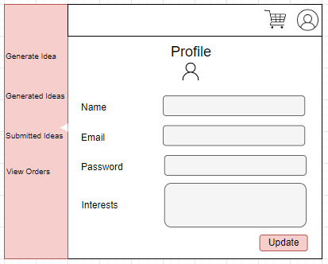

**As a logged-in user, I want to view and update my profile information, so that I can keep my personal details up to date.**

* **Acceptance Criteria:**
  + I can see my profile information, including fields for my name, email, password, and interests.
  + I can edit the fields to update my profile information.
  + There is an "Update" button that allows me to save the changes I made to my profile.
  + Upon clicking the "Update" button, my updated profile information is saved successfully.

**User Stories:**

**1. Landing Page:**

- As a visitor, I want to see a welcoming landing page with options to either log in or register, so that I can access the app’s features.

**2. Authentication:**

- As a new user, I want to register for an account by providing my email, password, and preferences, so that I can use the app and receive customized recommendations.

- Acceptance Criteria:

- Registration includes fields for email, password, allergies, and favorite ingredients.

- My registration details are saved in the user database.

- My preferences are stored in the preference database against my userID.

- As a returning user, I want to log in using my email and password, so that I can access my account and use the app’s features.

**3. Generating Recipe Ideas:**

- As a logged-in user, I want to create innovative recipe ideas by providing a title and description directly, so that I can suggest my own recipes.

- Acceptance Criteria:

- I can enter a title and description for my recipe idea.

- My idea is saved in the idea database for later use or submission.

- As a logged-in user, I want to interact with an AI chatbot to generate recipe ideas, so that I can get creative suggestions and refine them as needed.

- Acceptance Criteria:

- I can interact with the AI chatbot to get recipe prompts.

- The AI-generated idea is saved in the idea database for later use or submission.

**4. Submitting Ideas:**

- As a logged-in user, I want to submit my recipe idea to the vendor application, so that chefs can generate recipes based on my ideas.

- Acceptance Criteria:

- I can choose to submit my idea to the vendor application.

- My submission is saved in the vendor’s queue for review.

- As a logged-in user, I want to save my recipe idea for later, so that I can revisit it when needed without submitting it immediately.

- Acceptance Criteria:

- My unsent idea is saved in the idea database.

**5. Receiving and Viewing Recipes:**

- As a logged-in user, I want to receive up to three custom recipes generated by chefs based on my submitted ideas, so that I can review and select the ones I like.

- Acceptance Criteria:

- Recipes include a title, description, ingredients, preparation steps, and pictures.

- As a logged-in user, I want to view the recipes and see detailed information about each one, so that I can make an informed choice.

**6. Adding Recipes to Cart:**

- As a logged-in user, I want to select one or more recipes and add them to my cart, so that I can review my selection before placing an order.

- Acceptance Criteria:

- I can add selected recipes to the cart.

- The cart displays a summary of selected recipes and quantities.

**7. Placing an Order:**

- As a logged-in user, I want to place an order for the recipes in my cart, so that I can receive the recipes as per my selected quantities.

- Acceptance Criteria:

- I can review and confirm my order.

- The order details are stored on the customer orders table.

- The order is posted on the vendor orders table.

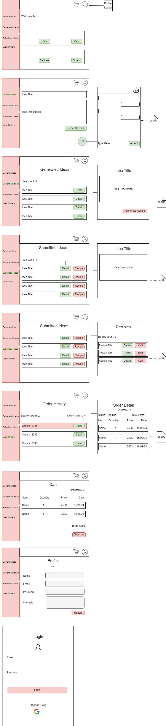

ER Diagram:

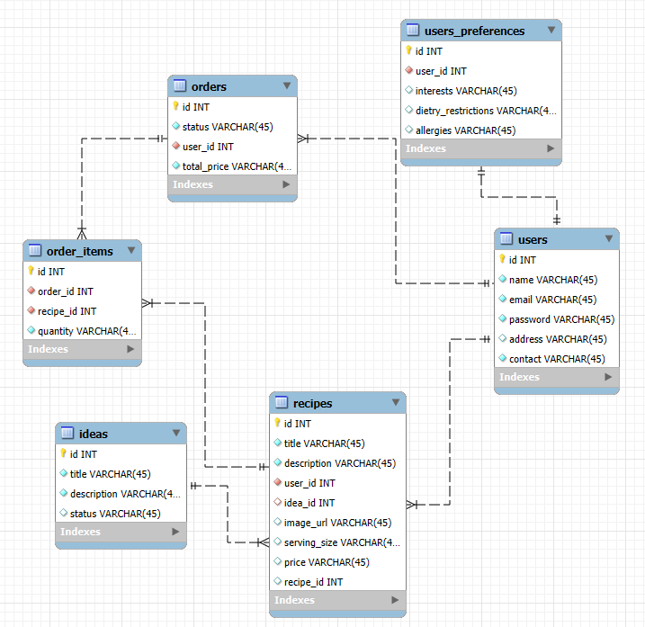

Designed Proposed after Meet:

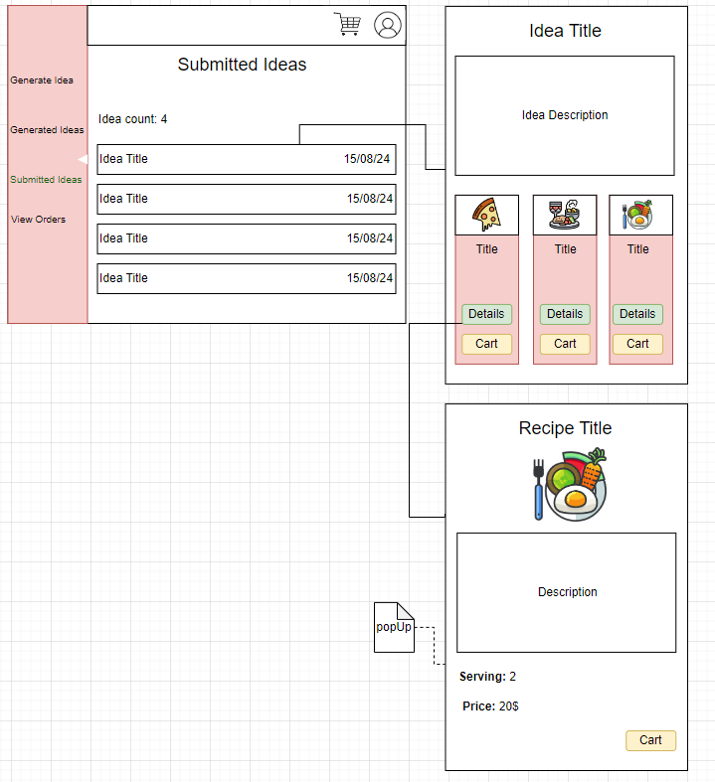

DB design after meet:

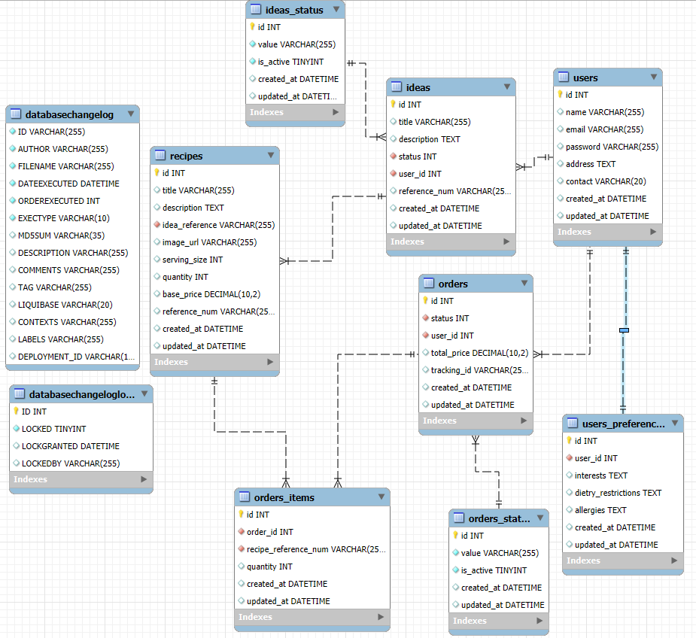

**Features:**

**- User Registration:** Allows users to sign up and update their interests.

- **Create Recipe Ideas via AI Assistant**: Users can input their own ideas or get help from AI Assistant to generate ideas by providing user-friendly prompts.

- **Submit Ideas:** Users can submit their ideas to request for custom recipe suggestions from chefs.

- **View Recipes:** Users can view custom recipes submitted by chefs against their ideas.

- **Order Recipe:** Users can select one or more recipes and order in their required quantities.

**API calls:**

1. **User Registration/Login Screen**

App: Customer

APIs:

POST /users/signup

Use: Create a new user account using google

POST /users/login

Use: Authenticate a user

POST /users/logout

Use: Log outs user

2. **User Profile Screen (After successful registration)**

**CREATE USER**

**GET USER BY USERNAME**

App: Customer

API:

POST /users/{userId}/profile

Use: Create profile such as personal details based on userId

3. **Generate Idea Screen**

App: Customer

APIs:

**Draft Screen**

POST /ideas

Use: Create a new idea (self-generated or AI-assisted) in customer's ideas table (Abdul Muiz)

4. **Generated Ideas Screen**

App: Customer

APIs:

GET /users/{userId}/submitted-ideas

Use: Retrieve user's ideas according to their statuses (Abdul Muiz)

**Submit Idea Screen**

**Frontend:**

GET / users/{userId}/draft-ideas

Use: View Draft Ideas (Abdul Muiz)

PATCH /ideas/{id}

Use: Update status of idea to submitted when customer submits an idea (Ahmad)

**Backend:**

POST api/v1/ideas **(call vendor API to submit idea)**

Use: Submit the idea to vendor's ideas table

|  |
| --- |
| Required fields:  Customer name:  Title  Description  Array of interests:  Array of dietary restrictions  Idea_code |

5. **Recipe** **Screen**

App: Customer

GET users/ideas/recipes/{id}(use query parameters if you need to pass idea code)

Use: Fetch recipes associated with ideas from recipes table

GET users/ideas/recipes/ (Optional not requirement – added just to allow customers to view order status after placing orders) (use query parameters pass idea id in @RequestParams)

Use: View order history of user

POST users/ideas/{id}/recipes

6. **Cart Screen**

App: Customer

API:

POST users/order

Use: Create a new order for a recipe in customer's order table

POST /vendor/orders **(call vendor API to submit order)**

Use: Place the order in vendor's order table

**Vendor App APIs (called by Customer App)**

POST /vendor/ideas

Use: Submit an idea to the vendor for recipe creation

POST /vendor/orders

Use: Place an order with the vendor

**Customer App APIs (called by Vendor App)**

POST /recipes

Use: Submit a generated recipe to the customer app

PATCH /orders/{id}

Use: Update the status of an order (e.g., when order is completed)